Report of Site Visit Team Findings-Radiography

Name of Program:
City/State:
Date(s) Visited:
Clinical Education
Setting(s) Visited
(City/State)
(City/State)
(City/State)
Name of Team Chair:
Team Chair Signature:
Name of Team Member:
Team Member Signature

The Report of Site Visit Team Findings is based on the Joint Review Committee on Education in Radiologic Technology (JRCERT) Standards for an Accredited Educational Program in Radiography,
adopted October 2013; implemented January 1, 2014.

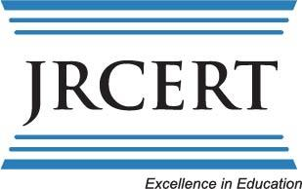
Joint Review Committee on Education in Radiologic Technology
20 N. Wacker Drive, Suite 2850
Chicago, IL 60606-3182
312.704.5300 ● (Fax) 312.704.5304
www.jrcert.org

Copyright © 2014 by the JRCERT (6/14)

Table of Contents

Introduction and Instructions 1

Confidentiality and Exit Statements 2

Accreditation Cycle Flow Chart 3

Standard 1: Integrity 4
Standard 2: Resources 8
Standard 3: Curriculum & Academic Practices 11
Standard 4: Health and Safety 14
Standard 5: Assessment 17
Standard 6: Institutional/Programmatic Data 20

Additional Information 23

Introduction and Instructions

I. Introduction

The Report of Site Visit Team Findings has been designed by the Joint Review Committee on Education in Radiologic Technology (JRCERT) to assure consistency in the evaluation of radiography programs. Utilize this instrument during the site visit. A separate narrative may be provided but is not required, unless the team believes exceptional findings necessitate additional explanation. One hard copy of the Site Visit Report must be submitted to the JRCERT.

The Report of Site Visit Team Findings, signed by each team member, is the required team report and is submitted by the team chair to the JRCERT office. The team members meet privately prior to the exit summation to ascertain team agreement on all the findings. The team will provide its findings to the program director prior to the exit summation to review the findings and to eliminate potential for misunderstanding. The exit summation must reflect team findings and relate only to the JRCERT Standards for an Accredited Educational Program in Radiography (the STANDARDS). Please refer to the protocol for the exit summation on page 2.

The program director has been provided with this instrument to promote familiarity with the evaluation procedure. It is recommended that the program provide a blank copy of the Report of Site Visit Team Findings to each attendee at the exit summation to aid in understanding the site visit team findings.

The primary functions of the site visit team are to verify information, to assess program outcomes, and to report findings. The JRCERT is responsible for determining the extent and degree of program compliance with the JRCERT STANDARDS.

II. Instructions for Completing the Report of Site Visit Team Findings

Assessing Objectives. A table is provided for each STANDARD to indicate the site visit team’s assessment of whether the program meets each objective. Record “N/A” if the objective does not apply to the program. For any objective checked “No” (i.e., program has not met the objective), the team must provide an explanation of how the program does not meet the objective. It is critical that this narrative cover each of the objectives the program is judged to have not met, since this assessment represents a potential deficiency in program compliance with the STANDARDS.

Program Strengths. This section can be used to outline how the program exceeds any of the objectives of the standard. Use this section to address as many of the STANDARDS and objectives as apply.

Suggestions. Site visitors may provide suggestions to the program that would help strengthen/improve it. Such suggestions should be sensitive to institutional prerogative, particularly as it relates to resource allocation. If suggestions are included in the report, sufficient supporting information must be provided.

This section can also be used to provide any other program information that may be taken into consideration relating to the standard.

Additional information. Space is provided at the end of this document for any additional information about the program that should be taken into consideration as part of the accreditation process.

Confidentiality and Exit Statements

Confidentiality Statement:

“As participants in this accreditation site visit, we are aware that we have access to accreditation information which shall remain confidential. We agree to respect and protect the confidentiality of all accreditation materials, recommendations, suggestions and
discussions prior to, during and following the site visit.”

Exit Statement:

“During this exit summation, I(we) will share with you the results of the team’s evaluation of the program and our findings regarding whether the program meets each of the objectives related to the Standards for an Accredited Educational Program in Radiologic
Sciences. This represents only the findings of the site visitors and does not constitute the official report of the JRCERT which will come from the JRCERT office within approximately three months. Once you have received the official report from the JRCERT, you will be required to respond to the official report before the JRCERT will take any accreditation action relative to the program.”

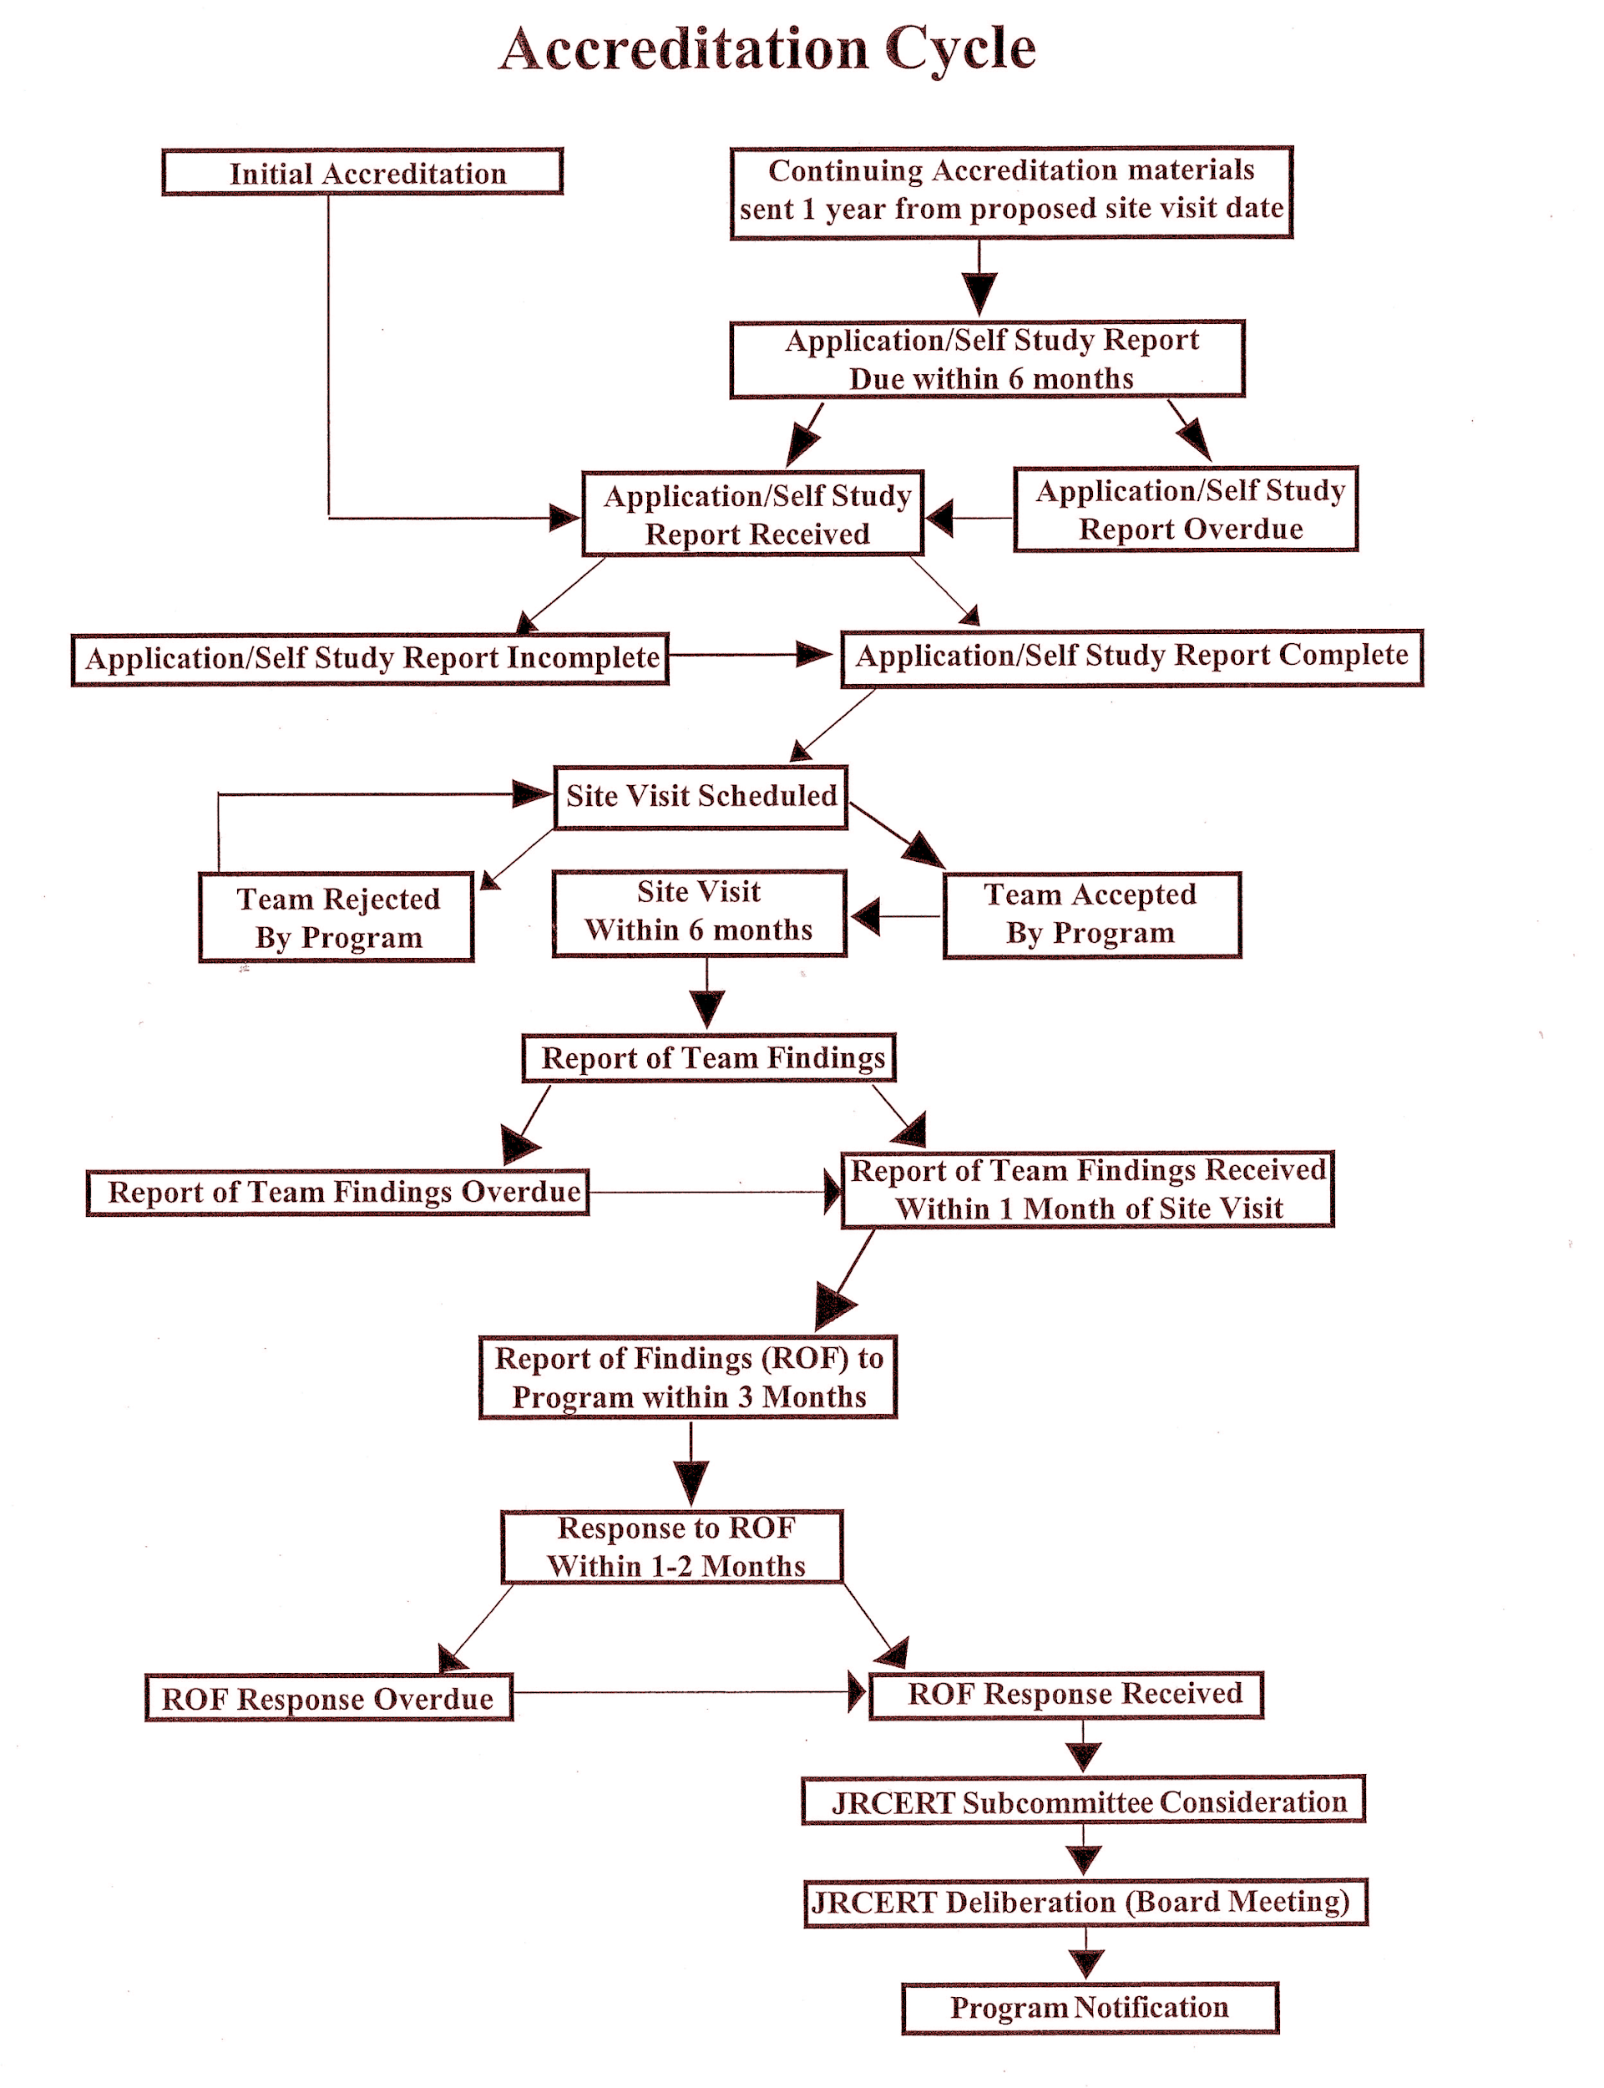
Standard One:
Integrity
Please use the space below to clearly explain the team’s rationale for indicating that a program does not meet an objective. An explanation must be provided for each objective indicated as “No”.

Please identify any program strengths related to Standard One.

Please provide background information for any team suggestions related to Standard One. You can also use this space to provide any other background information about this Standard that should be taken into consideration as part of the accreditation process.

STANDARD ONE: Integrity

The program demonstrates integrity in the following: Representations to communities of interest and the public, pursuit of fair and equitable academic practices, and treatment of, and respect for, students, faculty, and staff

Has Program Met Objective? |  | Objectives
Yes | No
 |  | 1.1 Does the program adhere to high ethical standards in relation to students, faculty, and staff?
 |  | 1.2 Does the program provide equitable learning opportunities for all students?
 |  | 1.3 Does the program provide timely, appropriate, and educationally valid clinical experiences for each admitted student?
 |  | 1.4 Does the program limit required clinical assignments for students to not more than 10 hours per day and the total didactic and clinical involvement to not more than 40 hours per week?
 |  | 1.5 Does the program assure the security and confidentiality of student records, instructional materials, and other appropriate program materials?
 |  | 1.6 Does the program have a grievance procedure that is readily accessible, fair, and equitably applied?
 |  | 1.7 Does the program assure that students are made aware of the JRCERT Standards for an Accredited Educational Program in Radiography and the avenue to pursue allegations of non-compliance with the STANDARDS?
 |  | 1.8 Does the program have publications that accurately reflect the program’s policies, procedures, and offerings?
1.9 Does the program make available to students, faculty, staff, and the general public accurate information about admission policies, tuition and fees, refund policies, academic calendars, clinical obligations,
grading system, graduation requirements and the criteria for transfer
credit?

STANDARD ONE: Integrity (continued)

Has Program Met Objective? |  | Objectives
Yes | No
 |  | 1.10 Are the program’s mission statement, goals, and student learning outcomes readily available to students, faculty, administrators, and the general public?
 |  | 1.11 Does the program document that the program engages the communities of interest for the purpose of continuous program improvement?
 |  | 1.12 Does the program have student recruitment and admission practices that are non-discriminatory with respect to any legally protected status such as race, color, religion, gender, age, disability, national origin, and any other protected class?
 |  | 1.13 Does the program have student recruitment and admission practices that are consistent with published policies of the and sponsoring institution and the program?
 |  | 1.14 Does the program have program faculty recruitment and employment practices that are non-discriminatory with respect to any legally protected status such as race, color, religion, gender, age, disability, national origin, and any other protected class?
 |  | 1.15 Does the program have procedures for maintaining the integrity of distance education courses?

Standard Two:
Resources
Please use the space below to clearly explain the team’s rationale for indicating that a program does not meet an objective. An explanation must be provided for each objective indicated as “No”.

Please identify any program strengths related to Standard Two.

Please provide background information for any team suggestions related to Standard Two. You can also use this space to provide any other background information about this Standard that should be taken into consideration as part of the accreditation process.

STANDARD TWO: Resources

The program has sufficient resources to support the quality and effectiveness of the educational process.

Has Program Met Objective? |  | Objectives
Yes | No
Administrative Structure
 |  | 2.1 Does the program have an appropriate organizational structure and sufficient administrative support to achieve the program’s mission?
 |  | 2.2 Does the program provide an adequate number of faculty to meet all educational, program, administrative, and accreditation requirements?
 |  | 2.3 Does the program provide faculty with opportunities for continued professional development?
 |  | 2.4 Does the program provide clerical support services, as needed, to meet all educational, program, and administrative requirements?
Learning Resources/Services
 |  | 2.5 Does the program assure JRCERT recognition of all clinical education settings
 |  | 2.6 Does the program provide classrooms, laboratories, and administrative and faculty offices to facilitate the achievement of the program’s mission?
 |  | 2.7 Does the program review and maintain learning resources to assure the achievement of student learning?
 |  | 2.8 Does the program provide access to student services in support of student learning?
Fiscal Support
 |  | 2.9 Does the program have sufficient ongoing financial resources to support the program’s mission?
 |  | 2.10 For those institutions and programs for which the JRCERT serves as a gatekeeper for Title IV financial aid, does the program maintain compliance with United States Department of Education (USDE) policies and procedures?
Standard Three

Curriculum and Academic Practices
Please use the space below to clearly explain the team’s rationale for indicating that a program does not meet an objective. An explanation must be provided for each objective indicated as “No”.

Please identify any program strengths related to Standard Three.

Please provide background information for any team suggestions related to Standard Three. You can also use this space to provide any other background information about this Standard that should be taken into consideration as part of the accreditation process.

STANDARD THREE: Curriculum and Academic Practices

The program’s curriculum and academic practices prepare students for professional practice.

Has Program Met Objective? |  | Objectives
Yes | No
 |  | 3.1 Does the program have a mission statement that defines its purpose and scope and is periodically reevaluated?
 |  | 3.2 Does the program provide a well-structured, competency-based curriculum that prepares students to practice in the professional discipline?
 |  | 3.3 Does the program provide learning opportunities in current and developing imaging and/or therapeutic technologies?
 |  | 3.4 Does the program assure an appropriate relationship between program length and the subject matter taught for the terminal award offered?
 |  | 3.5 Does the program measure the length of all didactic and clinical courses in clock hours or credit hours?
 |  | 3.6 Does the program maintain a master plan of education?
 |  | 3.7 Does the program provide timely and supportive academic, behavioral, and clinical advisement to students enrolled in the program?
 |  | 3.8 Does the program document that the responsibilities of faculty and clinical staff are delineated and performed?
3.9 Does the program evaluate program faculty and clinical instructor performance and share evaluation results regularly to assure
instructional responsibilities are performed?

Standard Four

Health and Safety

Please use the space below to clearly explain the team’s rationale for indicating that a program does not meet an objective. An explanation must be provided for each objective indicated as “No”.

Please identify any program strengths related to Standard Four.

Please provide background information for any team suggestions related to Standard Four. You can also use this space to provide any other background information about this Standard that should be taken into consideration as part of the accreditation process.

STANDARD FOUR: Health and Safety

The program’s policies and procedures promote the health, safety, and optimal use of radiation for students, patients, and the general public.

Has Program Met Objective? |  | Objectives
Yes | No
 |  | 4.1 Does the program assure the radiation safety of students through the implementation of published policies and procedures that are in compliance with Nuclear Regulatory Commission regulations and state laws as applicable?
4.2 Does the program have a published pregnancy policy that is consistent with applicable federal regulations and state laws, made known to accepted and enrolled female students, and contains the following elements?

__Written notice of voluntary declaration,
__Option for student continuance in the program without modification __Option for written withdrawal of declaration.

 |  | 4.3 Does the program assure that students employ proper radiation safety practices?
 |  | 4.4 Does the program assure that medical imaging procedures are performed under the direct supervision of a qualified radiographer until a student achieves competency?
 |  | 4.5 Does the program assure that medical imaging procedures are performed under the indirect supervision of a qualified radiographer after a student achieve competency?
 |  | 4.6 Does the program assure that students are directly supervised by a qualified radiographer when repeating unsatisfactory images?
 |  | 4.7 Does the program assure that sponsoring institution’s policies safeguard the health and safety of students?
 |  | 4.8 Does the program assure that students are orientated to clinical education setting policies and procedures in regard to health and safety?

Standard Five

Assessment

Please use the space below to clearly explain the team’s rationale for indicating that a program does not meet an objective. An explanation must be provided for each objective indicated as “No”.

Please identify any program strengths related to Standard Five.

Please provide background information for any team suggestions related to Standard Five. You can also use this space to provide any other background information about this Standard that should be taken into consideration as part of the accreditation process.

STANDARD FIVE: Assessment

The program develops and implements a system of planning and evaluation of student learning and program effectiveness outcomes in support of its mission.

Has Program Met Objective? |  | Objectives
Yes | No
Student Learning
5.1 Has the program developed an assessment plan that, at a minimum, measures the program’s student learning outcomes in relation to the following goals:

☐clinical competence ☐critical thinking
☐professionalism ☐communication skills

Program Effectiveness
5.2 Does the program document the following program effectiveness data:

☐ Five-year average credentialing examination pass rate of not less than 75 percent at first attempt within six months of graduation
☐ Five-year average job placement rate of not less than 75 percent within twelve months of graduation
☐ Program completion rates
☐ Graduate satisfaction
☐ Employer satisfaction

 |  | 5.3 Does the program make available to the general public program effectiveness data (credentialing examination pass rate, job placement rate, and program completion rate) on an annual basis?
Analysis and Actions
 |  | 5.4 Does the program analyze and share student learning outcome data and program effectiveness data to foster continuous program improvement?
 |  | 5.5 Does the program periodically evaluate its assessment plan to achieve continuous quality improvement?

Standard Six

Institutional/Programmatic Data
Please use the space below to clearly explain the team’s rationale for indicating that a program does not meet an objective. An explanation must be provided for each objective indicated as “No”.

Please identify any program strengths related to Standard Six.

Please provide background information for any team suggestions related to Standard Six. You can also use this space to provide any other background information about this Standard that should be taken into consideration as part of the accreditation process.

STANDARD SIX: Institutional/Programmatic Data

The program complies with JRCERT policies, procedures, and Standards to achieve and maintain specialized accreditation.

Has Program Met Objective? |  | Objectives
Yes | No
Sponsoring Institution
 |  | 6.1 Does the program document the continuing institutional accreditation of the sponsoring institution?
 |  | 6.2 Does the program document that the program’s energized laboratories are in compliance with applicable state and/or federal radiation safety laws?
Personnel
 |  | 6.3 Does the program document that all faculty and staff possess academic and professional qualifications appropriate for their assignments?
Clinical Education Settings
 |  | 6.4 Does the program establish and maintain affiliation agreements with clinical education settings?
 |  | 6.5 Does the program document that clinical education settings are in compliance with applicable state and/or federal radiation safety laws?
Program Sponsorship, Substantive Changes, and Notification of Program Officials
 |  | 6.6 Does the program comply with requirements to achieve and maintain JRCERT accreditation?

Additional Information

Please use the space below to provide any additional information.

Please email this document to mail@jrcert.org

Copyright© 2014 by the JRCERT
Subject to the condition that proper attribution is given and this copyright notice is included on such copies, the JRCERT authorizes individuals to make up to ten (10) copies of this work for non-commercial, educational purposes. For permission to reproduce additional copies of this work,
please write to:

JRCERT
20 North Wacker Drive
Suite 2850
Chicago, IL 60606-3182
(312) 704-5300
(312) 704-5304 (Fax)
email: mail@jrcert.org
www.jrcert.org

